Olzhas Kurikov

[ok34@hw.ac.uk](mailto:ok34@hw.ac.uk)

**Resonant Ultrasound Spectroscopy**

Analysis of thickness resonances to characterise a material

Master Thesis Project

16.01.2017 – 03.07.2017

Supervisor

Prof. Marc Desmulliez

Second supervisor

Prof. Thomas Speck

Co-supervisor

Dr. Anne Bernassau

Heriot-Watt University, Edinburgh

Albert-Ludwig’s University, Freiburg

1. **Introduction**

The aim of this project was to establish reliable setup to characterise a living material using resonant ultrasound spectroscopy. In the first stage of the project, the solid materials such as aluminium, glass and plastics were tested to prove that setup is well tested and ready to switch to a living materials such as plants. The experiments were performed with aluminium, glass and plastic due to existing elastic constants, hence it is straightforward to compare datasheet values to analysed data.

The main reason why exactly ultrasound resonant spectroscopy was used is that that by measuring transmission coefficient of a sample, RUS can infer parameters like thickness, density, attenuation coefficient, speed of sound and first order resonant frequency. Moreover, this technique is non-destructive, non-invasive, rapid and relatively inexpensive. Therefore, there is no damage on a sample which is significantly important for a plant samples, while running the experiment.

Coefficient of transmission of sound at normal incidence through each sample in the frequency range 0.6 MHz – 1.7 MHz was measured. For all cases, at least one thickness resonance was observed. From these measurements density, sound velocity, and attenuation of ultrasonic longitudinal waves were obtained and compared to available data provided in an articles or by manufacturers.

The method is based on frequency-domain analysis, by using the Fast Fourier transform, of pulse transmitted through a sample.

All the experiments were conducted in Biology department of Albert-Ludwig’s University of Freiburg city in Germany. And the required equipment, except oscilloscope (listed below) were transported from Heriot-Watt University, Edinburgh:

* Transducer
* Hydrophone
* Water tank
* Pulser/receiver
* DC coupler
* Oscilloscope

Results reveal that these resonances are strongly sensitive on different parameter changes which are discussed further in the report.

This report goes through all the steps and problems which are faced during the experiments and gives suggestions for further improvements.

All the needed information such as analysed data, Matlab and Python codes, setup instruction, the report can be provided via GitHub control system.

1. **Literature review and theory**
   1. **Fundamentals of ultrasound**

**2.1.1. Ultrasound**

The sound waves with frequencies above 20 kHz is called ultrasound and they are not in range for human hearing (William, 2012). Ultrasound is broadly used technique in different applications of medicine, food industry, factories and non-destructive testing. Sending and receiving of transmitted or reflected ultrasonic pulses allows ultrasonic devices to detect objects, defects and measure distances.

Ultrasound imaging (sonography) is mostly used in medicine to identify a health or gender of baby. In the non-destructive testing of materials or structures, ultrasonic waves are used to detect flaws. Industrially, ultrasound is used for cleaning, mixing and to accelerate chemical processes. In living environment, animals like bat and porpoises use ultrasound to locate prey and obstacles.

**Table I.** Frequency classification of Ultrasound

|  |
| --- |
| Frequency (Hz) Classification |
| 20 – 20.000 Audible sound  20.000 – 1.000.000 Ultrasound  1.000.000 – 30.000.000 Diagnostic ultrasound |

**2.1.2. Ultrasonic waves**

In ultrasound, high-frequency sound waves travel through the material being tested and information about parameters of a material are then obtained by measuring the type and interaction angle between the sound wave and the testing sample. When the sound waves are introduced within a sample, alternating molecular compression and rarefaction takes place. There are 2 modes of waves which propagates through a solid material:

* Longitudinal waves (pressure waves)
* Transverse waves (shear waves)

Longitudinal waves, where oscillation happens in the same direction as the wave is moving. This type of wave can be generated in liquids, solids and gases. In transverse wave, the oscillation occurs perpendicular to the direction that the wave is travelling in. This type of wave is propagated in solid structures only. Figure 1 represents these types of waves.

**Figure 1.** Longitudinal and transverse waves (http://www.keywordsuggests.com/)

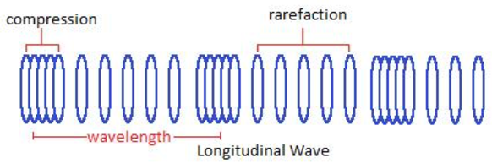 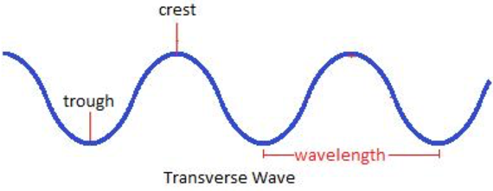

**Wave characteristics**

An area of compression and a neighbouring zone of rarefaction identify one cycle of an ultrasound wave. A wave cycle can be depicted as a graph of local pressure in the medium versus distance I along the direction of the wave (Figure 2). The wavelength is the distance covered by one cycle. The number of cycles per unit time introduced in the medium each second is referred to as the frequency, and measured in unit of hertz, kilohertz or megahertz, where 1 Hz is 1 cycle per second. The maximum height of the wave cycle is referred to amplitude of the ultrasound wave. And the multiplication of the frequency ($v$) and the wavelength (λ) is the velocity of the wave and expressed as below (William, 2012):

$c=vλ$ (1)

**Figure 2.** Characteristics of an ultrasound wave

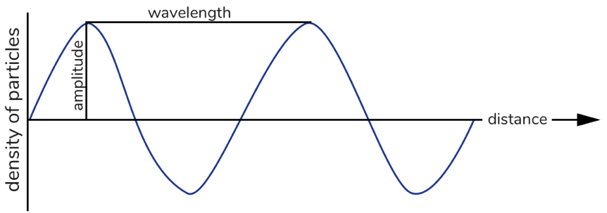

**Interaction of waves**

Interference of waves occurs when to waves meet. There are two extremes of waves’ interference: constructive and destructive. In constructive interference peak meets with other peak, they are said to “in phase” and in destructive interference the waves are “out of phase”, hence two waves cancel each other out. Waves experience constructive interference when their amplitudes added, whereas waves undergoing destructive interference can completely nullify each other (Figure 3).

**Figure 3.** Interference of two waves

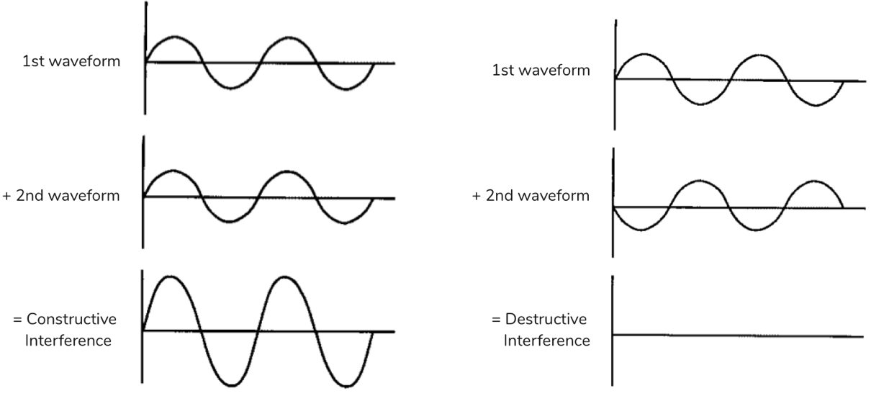

**Reflection and Transmission**

The part of incident energy reflected from the surface directly depends on the different in acoustic impedance of the material on opposite sides of the interface. The acoustic impedance can be expressed as follows:

$Z= ρc= \frac{ωρ}{k}$ (X)

where Z is acoustic impedance of medium, $ρ$ is density of the medium and $c$ is the speed of sound in the medium, $ω$ is angular frequency and $k$ is wavenumber (explained below).

In a case of one layer material the reflection coefficient $α_{R}$ is shown below (ultrasound wave incident perpendicular):

$α_{R}={(\frac{Z_{2}-Z_{1}}{Z_{2}+Z_{1}})}^{2}$ (X)

where Z1 and Z2 are the acoustic impedances of two different media. The fraction of the incident energy is transmitted through the media and can be described by transmission coefficient:

$α_{T}=\frac{4Z_{1}Z_{2}}{{\left(Z_{1}+Z_{2}\right)}^{2}}$ (X)

Therefore, it is clear, that:

${ α}_{R}+α_{T}=1$ (X)

A large impedance mismatch occurs at an interface, when the most of energy if reflected, and only small portion is transmitted across the interface. For instance, ultrasound energy is significantly reflected at air-

tissue and air-water interfaces, because the air impedance is much less than tissue or water.

**Refraction**

The direction of incident beam is changed once it crosses an interface obliquely between two media. If the velocity of ultrasound is higher in a second medium, then the beam enters this medium at less steep angle. This behaviour of ultrasound beam is called refraction. The relationship between incident angle and refracted angle can be described by Snell’s law:

$$\frac{sine of incident angle}{sine of refractive angle}= \frac{velocity in incidence medium}{velocity in refractive medium}$$

$\frac{{sinθ}_{i}}{{sinθ}_{r}}= \frac{c_{i}}{c_{r}}$ (X)

**Figure 4.** Reflection, refraction and transmission of ultrasound

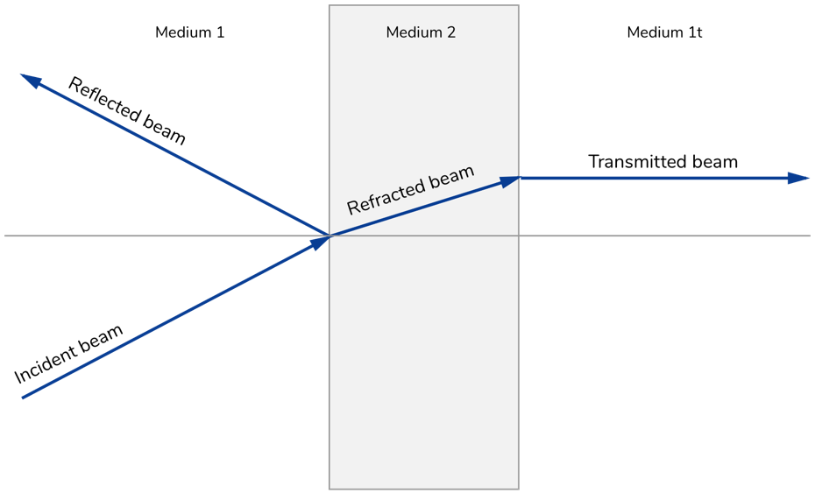

**Note to Figure 4:** The beam hits the medium 2 at an angle of $θ_{i}$. A portion of the energy is reflected at an angle of $θ_{r}$ and part of energy goes through at an angle of $θ_{ref}$.

**2.1.3. Ultrasound intensity**

As an ultrasonic waves pass through a medium, it transfers energy through the medium. The amount of energy transport is called “power”.

The rate of flow of energy (power) per unit of cross sectional area is called intensity. Intensity is commonly described relatively to another intensity; for example, the intensity of ultrasonic waves transmitted through medium may be compared with that of the ultrasound sent into the material. The intensity is measured in a logarithmic scale, since it is the most appropriate for recording data over a range of many orders of magnitude. The decibel scale is used in acoustics:

$dB=10log\frac{I}{I_{0}}$ (X)

where $I_{0}$ is the reference intensity. Due to intensity is power per unit area and power is energy per unit time, it is possible to write above expression as:

$dB=10log\frac{Power}{{Power}_{0}}=10log\frac{E}{E_{0}}$ (X)

Ultrasound wave intensity is allied to maximum pressure ($P_{m}$) in the medium by the following expression:

$1= \frac{P_{m}^{2}}{2ρc}$ (X)

where $ρ$ is the density of the medium and $c$ is the speed of sound in the medium. When we substitute Eq. (X) for $I$ and $I_{0}$ in Eq. (X):

$dB=10log\frac{P_{m}^{2}/2ρc}{{{(P}_{m}^{2})}_{0}/2ρc}=10log\left[\frac{P_{m}}{P_{m0}}\right]=20log\frac{P_{m}}{P_{m0}}$ (X)

While comparing two pressure waves, Eq. (X) can be used directly; the pressure does not have to be converted into intensity to find dB value.

**2.1.4. Ultrasound velocity**

The speed of an ultrasonic wave through a medium changes and it depends on the physical properties of the medium. The velocity of an ultrasonic wave is relatively low in low-density media such as air and gases, since the molecules in them move over relatively large distances before they impact neighbouring molecules. In solids, the molecules are limited in their motion, and the ultrasound velocity is relatively high. In

another hand, liquids demonstrate ultrasound velocities in-between those, gases and solids.

**Table II.** Approximate velocities in different medium

|  |  |
| --- | --- |
| Nonbiological material Velocity (m/s) | Biological material Velocity (m/s) |
| Aluminium 6400  Plastic 2680  Water (degassed) 1480  Glass 5640  Air 330 |  |

**2.1.5. Ultrasound attenuation**

As an ultrasound beam penetrates a medium, energy decreases due to absorption, reflection and scattering, so to say, the attenuation of ultrasound is when sound intensity decreases exponentially with distance from the source.

Donation to attenuation of an ultrasound beam can include:

* Reflection
* Absorption
* Scattering
* Refraction
* Diffraction
* Interference

Ultrasound energy is absorbed by a medium when the fraction of the beam’s energy turned into other forms energy, like an increase in the arbitrary motion of molecules. Ultrasound is reflected back when the angle of reflection is same as incident angle. If the part of beam changes direction in a less orderly manner, this phenomenon is called “scattering”.

The attenuation of ultrasound in a medium is expressed by attenuation coefficient α in units of dB/cm or Nepers per meter(1 Np = 8.686 dB). The attenuation coefficient is the total amount of individual coefficients for scattering and absorption and can be expressed as follows:

$A= A_{0}e^{-αx}$ (X)

where α is attenuation coefficient, A is amplitude of the ultrasound wave, A0 is the initial amplitude and $x$ is the distance the wave has travelled through the medium. (McClements and Gunasekaran, 1997)

**Table III.** Attenuation coefficient $α$ for 1 MHz ultrasound

|  |
| --- |
| Medium α (dB/cm) |
| Blood 0.18  Fat 0.16  Muscle 3.3  Water 0.0022  Bone 20  Brain 0.85 |

**Note to Table III:** The given figures in table are relative and may vary with both the origin and condition of the biological sample.

* 1. **Ultrasound transducers**
     1. **Introduction to transducers**

A transducer is certain device that transforms one form of energy into another. And ultrasound transducer converts electrical energy into ultrasound energy and in reverse way. Transducer for ultrasound consists of piezoelectric crystals or elements such as quartz (silica).

* + 1. **Piezoelectric effect**

A piezoelectric effect is exhibited whenever a pressure is applied, develop voltage across opposite surfaces. This effect is used to produce ultrasound incident wave when electrical signal is applied to the transducer. Application of the voltage across the crystal causes its deformation – expansion or compression depending upon voltage polarity.

A definition of transducer is known as a fraction of applied energy that is converted into wanted energy mode. For ultrasound transducer, this definition described with electromechanical coupling coefficient; it varies whether electrical or mechanical energy is applied:

$$k_{c}^{2}=\frac{Mechanical energy is converted into electrical}{Applied mechanical energy}$$

If electrical energy is applied:

$$k_{c}^{2}=\frac{Electrical energy is converted into mechanical}{Applied electrical energy}$$

Some $k_{c}$ values for transducers are listed below in Table IV

**Table IV.** Properties of piezoelectric crystals

|  |
| --- |
| Materials Electromechanical coupling coefficient ($k_{c}$) |
| Quartz 0.11  Rochelle salt 0.78  Barium titanate 0.30  Lead zicronate titanate (PZT-4) 0.70  Lead zicronate titanate (PZT-5) 0.70 |

* + 1. **Transducer design**

The piezoelectric crystal is essential part of any transducer. A crystal generates its greatest response at resonant frequency. The resonance frequency of ultrasound transducer depends on the thickness of crystal. As the crystal goes through one

complete cycle form shrinking to expansion to the next shrinking, compression waves move in direction of centre of the crystal form opposite side of its face. It is complicated to “drive” crystal with one wavelength thickness due to the compression waves arrive at opposite surfaces just as the next shrinking starts, hence the energy is wasted. However, if the thickness of crystal is equal to half of wavelength, a compression waves happens at the crystal interface just as expansion begins to occur. A crystal with half wavelength resonates at a frequency:

$f=\frac{c}{λ}=\frac{c}{2t}$ (x)

The plastic sealing of crystal has a thickness of ¼ $λ$ and it is called quarter-wavelength matching layer.

**3 Experimental work**

**3.1. Theory and introduction to technique**

After discussed techniques that are already in use, this section will introduce a method which was approached during the entire project.

The main principle of the technique is to measure spectra of the transmission coefficient at normal incidence of different samples such as aluminium and glass in the frequency range of the first order thickness resonance that can be explained by theoretical model which is applied to a homogenous or flat plates. In this case a simple theoretical expression can be derived for the transmission coefficient (Eq. X), that depends on the acoustic impedance of sample and surrounding medium (water), the thickness of the sample, ultrasound velocity and attenuation in the sample and resonant frequency of the sample.

$T= \frac{2Z_{1}Z_{2}}{2Z_{1}Z_{2}coskt+i(Z_{1}^{2}+Z_{2}^{2})sinkt}$ (X)

where Z1 and Z2 are acoustic impedances for the sample and surrounding medium respectively, t is the thickness of the sample and k is attenuation coefficient.

Transmission coefficient (T) is found as the ratio between transmitted and incident signal’s amplitudes and is given by T = γ2 (derived below). The plot of T against frequency T(f) tends to have a pattern of thickness resonances located at:

${ ω}_{n}= \frac{2πϑn}{2t}, n=1,2,3,….,$ (X)

where ν is the velocity in the sample and t is the thickness of the sample. For the project experimental setup, the first resonant frequency was identified so Equation above can be interpreted as follows:

${ f}_{R}=\frac{ϑ}{2t}$ (X)

In addition for the experimental setup it is true that T= (insertion loss)2 and Φ = ϕ(γ) - tω / υ, ϕ(γ) is the phase of γ.

So if thickness is known and T(f) is measured, then solution of the inverse problem allows to retrieve the following: velocity, attenuation and density.

In contrast, when reverberations inside the sample are insignificant, then velocity in sample can be found directly from phase difference (Δφ), t and velocity of water:

$ϑ\left(ω\right)= \frac{t}{\frac{t}{ϑ}-\frac{∆φ}{ω}}$ (X)

Existence of reverberations inside the sample gives a phase shift and γ goes to be a complex magnitude. Therefore this cancels the use of Eq(X), but at

**3.1.1. Experimental setup**

The water immersed ultrasound spectroscopy setup consists of a cylindrical ultrasound transducer (centre frequency of 1 MHz, and diameter is 23 mm) and a hydrophone (1mm long needle probe connected to a preamplifier, power supplied with a DC Coupler, both are Precision Acoustics, Dorchester, UK). They are situated so, that the transducer and hydrophone are facing each other with sample holder in between. The setup is immersed in water tank with dimensions of….. And hydrophone and transmitter transducer are connected to a pulser/receiver (Pulser/Receiver DPR300, JSR Ultrasonic, Imaginant, Pittsford, USA; 475V and 35MHz bandwidth). The oscilloscope (Infinii Vision DSO-X 3204T digital storage oscilloscope, Keysight Technologies, Wokingham, UK) as shown in Figure X (schematic and actual look).

During the project the setup was improved to solve issues with splitting peaks which is discussed in “Setup improvements to reduce the effect of shear wave” section. However, the most of structure remained same. Transducer, hydrophone and sample are attached by holders to slides on a scaffold. Transducer, hydrophone and sample holders are completely moveable in x-axis as well as height in y-axis for sample holder (Figure X).

A sample can be easily changed while the setup is in water. The sample holder have different frames depending on sample’s dimensions. Eventually the water tank has to be filled specifically with distilled, degassed or with deionised water, since the transducer can function only with these types of water.

**Figure X.** Experimental setup. Transducer and hydrophone are immersed in a fish tank filled with distilled water. The pulser/receiver drives the transducer to launch a signal pulse through a sample to the hydrophone, from where it is then transferred back to the pulser/receiver again for amplification and lastly the signal is displayed on the scope.

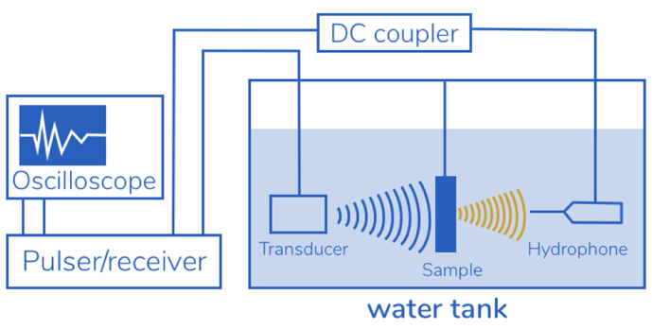

To follow-up, each of the devices were described shortly

**Transducer**

The underwater acoustic channel has unique properties that must be considered in order to properly choose transducers. The underwater acoustic transducers are microphones specifically designed to function underwater for listening or recording to sound under the water.

The provided transducer in this project was PA752, with 23mm in diameter and centre frequency of 1 MHz. A sample therefore had to be carefully selected to match the resonant frequency of the transducer (~0.61 – 1.3 MHz). This transducer is made of piezo-ceramic materials which are characterised by having good electrical to mechanical transformation abilities and low internal damping. And these properties make it to produce good resonant transducers.

PA752 is supplied with an integral quarter wave matching layer for effectively coupling the high characteristic acoustic impedance of piezo-ceramics into the 1.5 MRayls load that is presented by water. Supplementary, it is including complex electrical impedance which is transformed to ~50 Ohms. That ensures that favourable power transfer into the transducer from typical 50 Ohm output impedance amplifiers, in the project case it is pulser/receiver.

**Pulser/Receiver**

The provided DPR300 pulser/receiver (Figure X) is ultrasonic pulser/receiver with a vastly low noise receiver. This apparatus controls include receiver gain, high and lowpass filters cutoff frequency selection, pulse energy, pulse amplitude, pulser impedance, damping level, pulse-echo/through transmission option to select, pulse repetition rate, and pulser trigger source select.

Figure X. DPR300 Pulser/receiver is instrument for exacting applications. The picture below shows front panel of the apparatus.

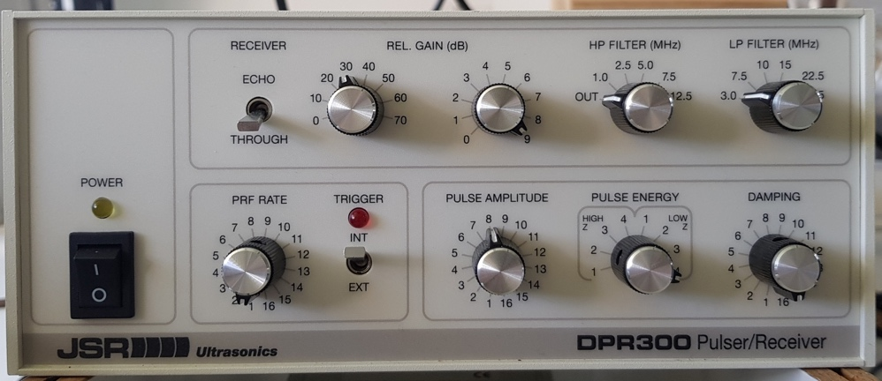

The DPR300 is specifically designed for amplification purposes. The rapid-recovery receiver is fully protected from electromagnetic noise and any interference to guarantee a high SNR. In addition, the pulse energy, pulser impedance and pulse amplitude are easily adjustable to optimize the excitation pulse for a specific application and transducer which is done later in characterisation section of the report.

As the name says the instrument is divided into two parts, pulser and receiver and their specifications are indicated in Table X

**Table X.** The pusler/receiver is consist of two parts, pulser and receiver and each of them have specific goals depending on application. The Table shows the types of settings they have.

|  |  |
| --- | --- |
| Pulser | Receiver |
| Pulse type Negative spike pulse  Pulse Amplitude Varying from 100V to 475V. Amplitude depends upon Energy, Damping and Impedance control settings.  Pulser Energy Can be chosen in 4 steps  Pulse Impedance High/Low, user selectable  Pulse Duration 10 to 70 ns FWHM for 50 Ohms load.  Damping 16 damping settings: 24.6, 26.3, 28.1, 30.3, 32.7, 35.7, 39.2, 43.5, 48.7, 55.6, 64.5, 76.9, 95.2, 125, 182, 333 Ohms.  Mode Pulse-echo or through transmission  Pulser Repetition Rate Internal 100 – 5 kHz with 16 steps  Pulse Trigger Source Internal oscillator or external source | **Gain**  -13 to 66 dB in 1 dB steps  **Phase** 0 degree (non-inverting)  **Input Impedance** 500 Ohms (through-transmission)  **Bandwidth** 0.001 to 35 MHz (-3 dB)  **High Pass Filter** 1.0, 2.5, 5.0, 7.5, 12.5 MHz  **Low Pass Filter** 3, 7.5, 10, 15, 22.5 (35 MHz BW)  **Output Impedance** 50 Ohms |

**Hydrophone**

A hydrophone is a device to listen to or pickup an acoustic energy underwater. A hydrophone transforms acoustic energy into electrical energy. The supplied hydrophone is

1.0mm Needle Hydrophone by Precision Acoustics (Figure X). The needle has formidable sensitivity and well fitted for the measurements at low frequency. Other additional information about hydrophone can be found on GitHub repository.

**Figure X.** 1.0mm Needle Hydrophone by Precision Acoustics. The instrument is specifically designed to pickup an ultrasound under the water.

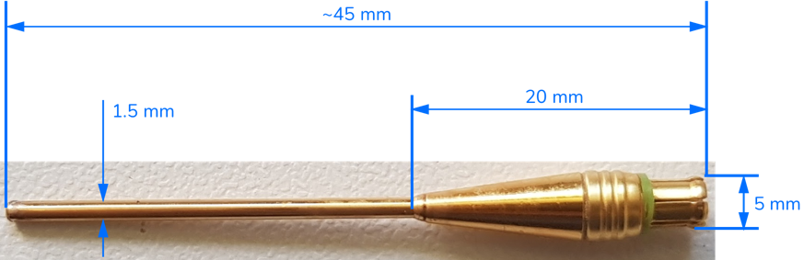

**Oscilloscope**

The general purpose of oscilloscope is to observe of constantly changing signal voltages in two dimensional graph as function of time.

In this project the oscilloscope from KEYSIGHT InfiniiVision DSO-X 2022A was utilised.

The series of experiments were conducted in order to ensure that any changes of settings in the scope give certain variation in signal while collecting a data. The papers about these experiments can be found in GitHub repository. Therefore, it was clear that the horizontal resolution (seconds per division) had to be set to the same during the measurements with and without a sample as well as the vertical resolution. Also the “delay time” to shift the signal in the display to fit an entire signal must stay identical for both, with and without sample measurements (Figure X). Another consideration is to change trigger option to “External”, since the signal was triggered already by pulser/receiver internally.

**Figure X** depicts the top bar of the scope’s display where vertical, horizontal resolutions and delay time are situated to observe any user change.

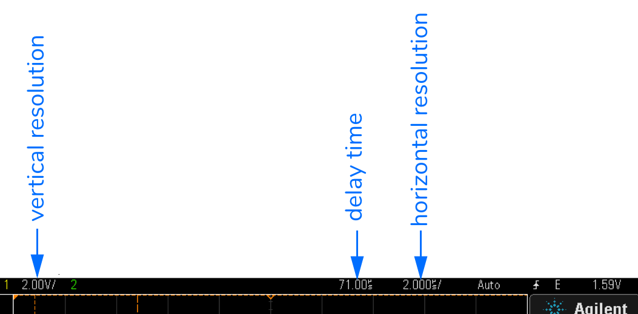

**Sample holder/sample frames**

The sample holder is structured so that it can placed between the transducer and hydrophone. There is a frame where a sample can be put in-between and three types of frames (Figure X) with different size were designed, so depending upon the sample’s dimension certain frame can be selected.

**Figure X**. The frames for sample holder with a variation of dimensions depending on sample sizes. There are three different square sample frames with 5 cm side length and inner squares of 3.08cm, 2.1cm and 4.08cm.

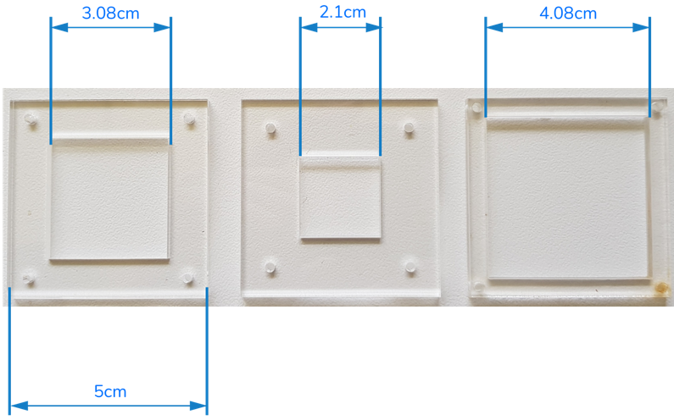

**3.1.2. Data Collection and Analysis Process**

Collecting and analysing data can be separated into two major parts, MATLAB and implemented Algorithm in Python, and short overview of data collection/analysis can be seen in Figure X.

**Figure X** shows data collection and analysis process steps. A raw data is first collected from the scope as a .csv file for Matlab where time domain is converted into frequency domain and gives ready file for Python algorithm.

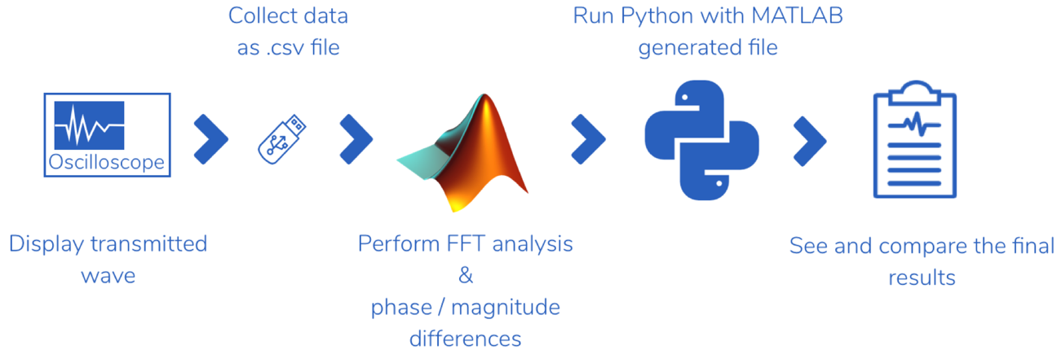

The measuring and analysing procedure is based on a conventional through-transmission technique and it is as follows. Transmitter is driven by a negative pulse tuned to the centre frequency of the transducer and is finally received by the hydrophone. The signal pulse is

measured at normal incidence (visually set at normal angle) to measure the amplitude and the phase of the coefficient of transmitted signal in the frequency domain. First the signal received without any sample and measured data is collected as a .csv file from the oscilloscope (voltage vs. seconds). The same procedure is applied when a sample is inside the tank. The next step of process occurs in MATLAB.

**Data Analysis in MATLAB**

The process of analysis in MATLAB has two major sections, in the first part it does the Fast Fourier Transform analysis on the raw data which is retrieved from the scope. To obtain the frequency and phase of a sample the FFT was used and script is shown in Figure X below.

**Figure X.** MATLAB script 1.1 to make analysis with initial data, in this case it is glass with 3mm thickness. In this section the .csv file was just imported and plotted (original signal: seconds versus voltage)

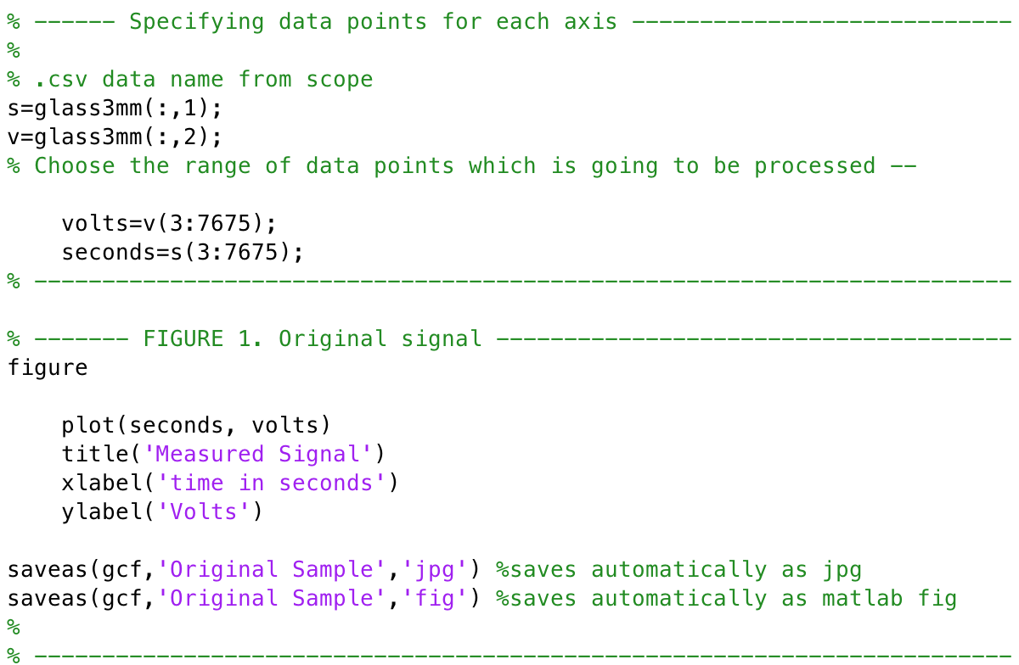

**Figure X.** MATLAB 1.2 script shows implemented FFT algorithm to obtain convert time to frequency domain as well as to obtain phase and amplitude spectrum from unprocessed data (.csv file)

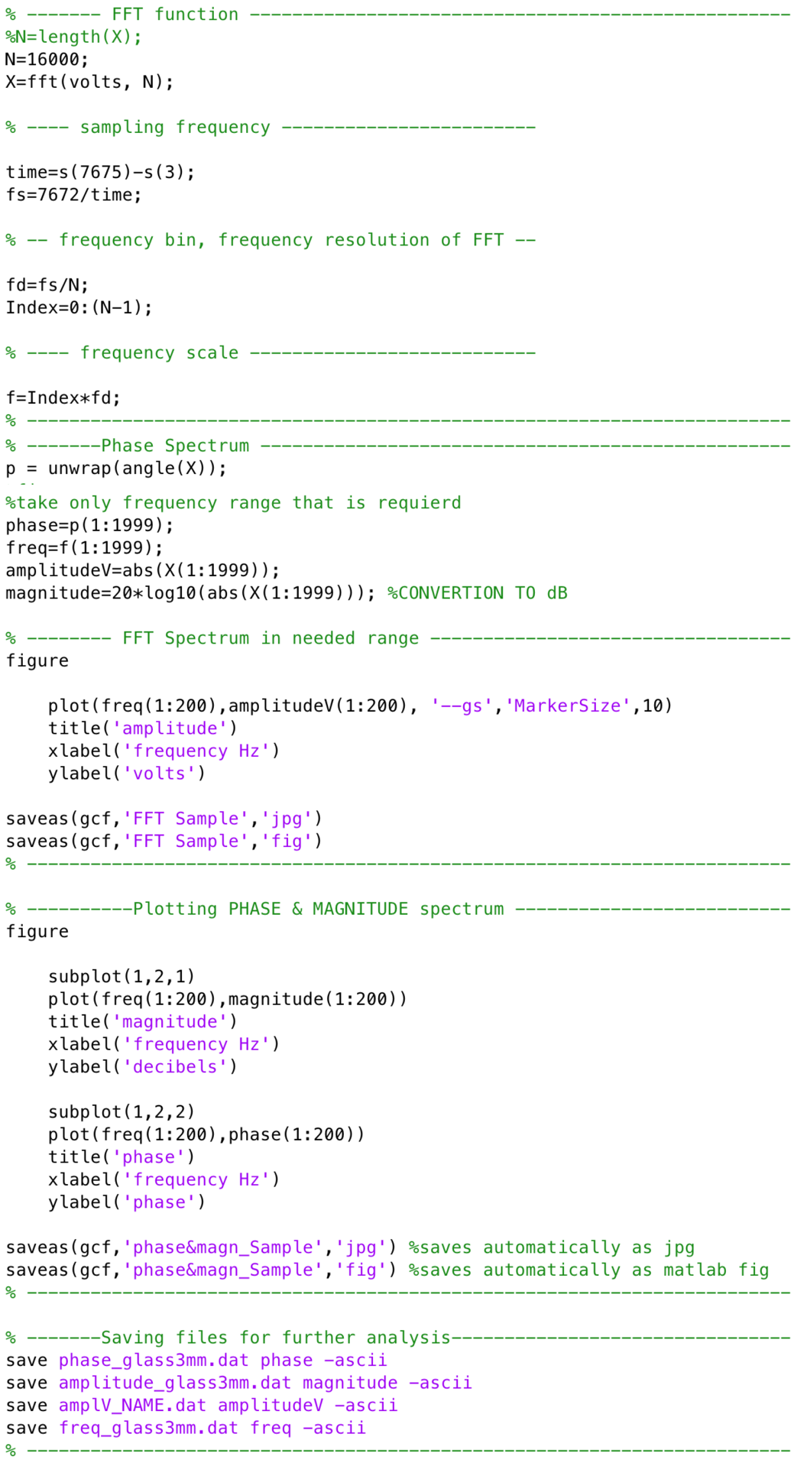

First the signal received without any sample is acquired and FFT (amplitude and phase) are calculated and saved as reference. Then the sample is put in between the transducer and hydrophone at normal incidence, and FFT analysis was made as well as amplitude and phase spectra are again measured and saved for the second part of MATLAB code (Figure X).

**Figure X.** MATLAB 2.1 shows the following procedure after the amplitude and phase spectrum are ready and here the final .dat file for python is generated. This script is short version since in python only required (first order resonance) region was analysed and during the project several filters were applied to enhance the FFT difference signal. The extended version and other files can be found in GitHub service.

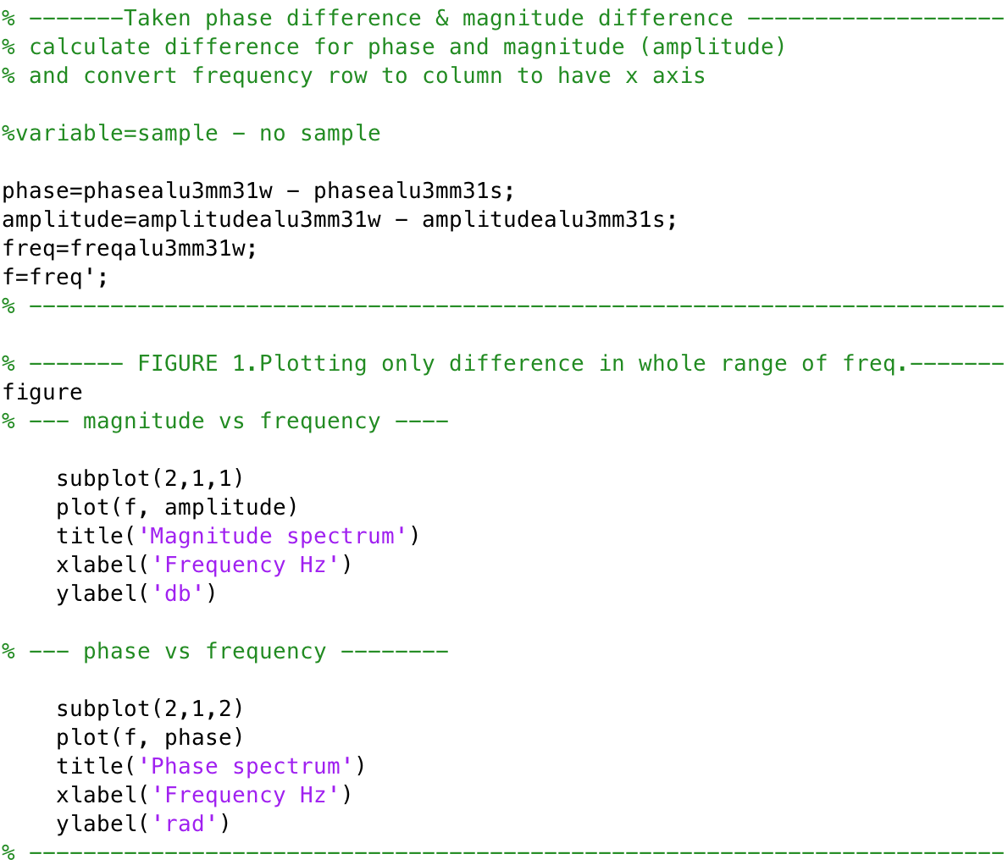

From MATLAB 1.2 file there are amplitude and phase spectrums for with and without sample which are saved as a .dat files, hence to obtain material properties from the spectrum, the incident pulse (without sample) and the transmitted pulse (with sample) are compared by taking difference of phase shift and insertion loss. After the result was introduced into the python algorithm in Enthought Canopy (version 1.7.2) software to retrieve characteristics of sample.

**Data Analysis in Python**

The purpose of python code was to extract material properties of a sample (density, thickness, ultrasound velocity and attenuation) from phase and amplitude spectra of the transmission coefficient measured at normal incidence where first order thickness resonance is observed.

**3.2. Results and discussion**

As stated in introduction section, the purpose of project was to establish reliable setup to have reproducible and repeatable data. The experimental setup is straightforward and data analysis process is fast and simple. However, since there is large amount of parameters there were certain issues regarding the equipment and the data analysis process. They were tested accordingly in order to investigate how the changes of different parameters can influence on data results. All the measurements were performed with solid materials, mostly aluminium sample. The reason behind of experimenting on solid materials is it is simple to compare the retrieved results with literature values or data sheet. That proves that the setup and technique is functioning in correct way and data is reproducible before moving into biological species. The subsections below will show how the results change according to variation of parameters.

**3.2.1 Measurements with samples on default settings**

Before understanding the variation of parameters, the default settings for pulser/receiver and oscilloscope (Frederike, 2016) were used to obtain and compare the results afterwards. The experiments were conducted only with samples which were available at that time in the lab with different thicknesses to see the results and continue ….. Default settings are depicted in a Table X below:

**Table X.** Settings for pulser/receiver and oscilloscope by default

|  |  |
| --- | --- |
| Pulser/receiver | Oscilloscope |
| Relative gain 38 dB  High pass filter out  Low pass filter 35 dB  Pulse repetition frequency: 1 (100Hz)  Pulse amplitude 11  Trigger Internal (INT)  Pulse energy High 3  Damping 2 | Amplitude 5 V/division  Time 2μs/division  Delay 72.56 μs |

All the lines represented in pictures:

* Red line on the graphs is measured data without sample
* Yellow line on the graphs is measured data with sample
* Blue line on the graphs is the difference between measured data with sample and without sample
* Section with bold blue line on magnitude graphs is the measured data which is process in python

**Experiment 1. Glass with 2 mm thickness**

**Figure X1.**  Detail in the phase and magnitude spectrum of the first received pulse without and with sample between transducer and hydrophone. The graph shows MATLAB output

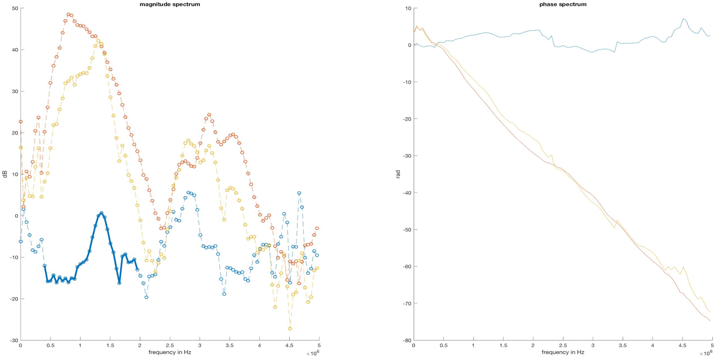

**Figure X2.**  Transmission coefficient spectra with fitted theoretical transmission coefficient of a measured glass sample.

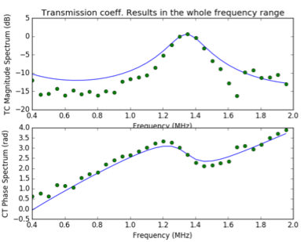

**Table X1.** The results obtained from python algorithm compared with calculated and/or literature data for further investigation on the issues of setup and/or data analysis.

|  |  |
| --- | --- |
| Parameters Python output | Calculated and/or literature data |
| Thickness (mm 0.98  Velocity (m/s) 2726  Density (kg/m3) 4293  Resonant frequency (MHz) 1.35 | 1.92  4540  2719  1.18 |

**Experiment 2. Glass with 3 mm thickness**

**Figure X2.** Detail in the phase and magnitude spectrum of the first received pulse without and with sample between transducer and hydrophone. The graph shows MATLAB output

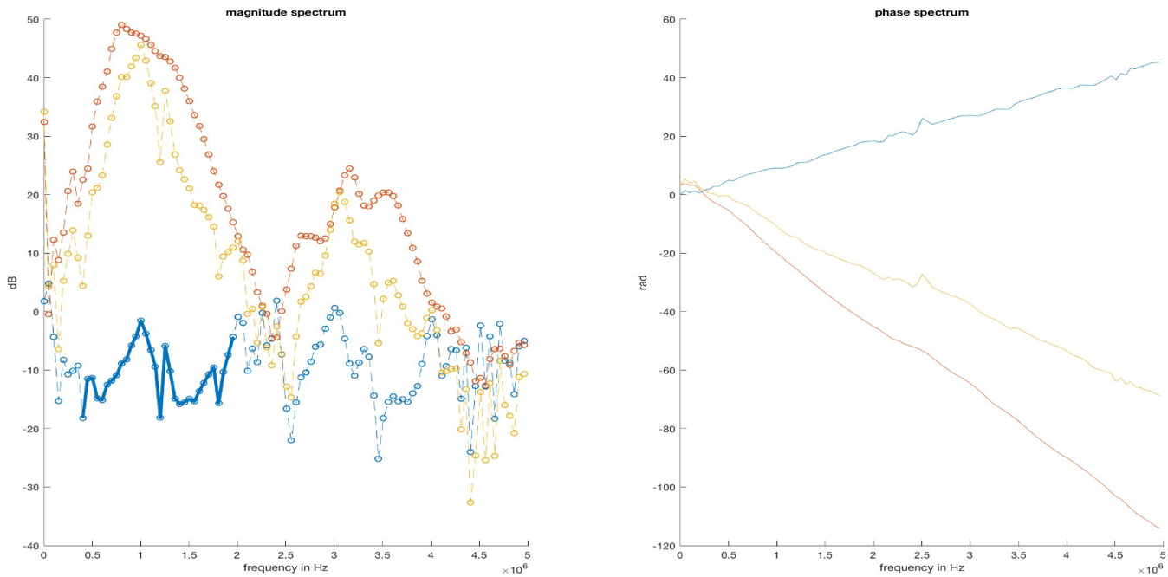

**Figure X3.**  Transmission coefficient spectra with fitted theoretical transmission coefficient of a measured glass sample.

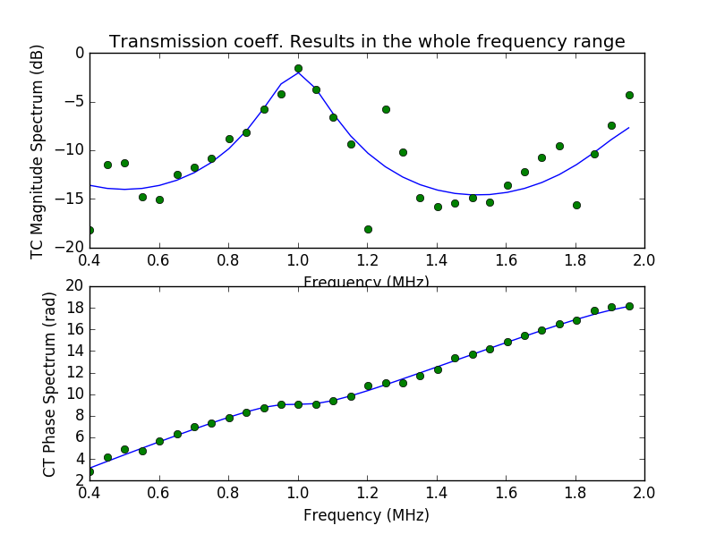

**Table X2.** The results obtained from python algorithm compared with calculated and/or literature data for further investigation on the issues of setup and/or data analysis.

|  |  |
| --- | --- |
| Parameters Python output | Calculated and/or literature data |
| Thickness (mm 2.80  Velocity (m/s) 5662  Density (kg/m3) 2596  Resonant frequency (MHz) 1.00 | 2.72  4540  2683  0.84 |

**Experiment 3. Aluminium with 3 mm thickness**

**Figure X5.**  Detail in the phase and magnitude spectrum of the first received pulse without and with sample between transducer and hydrophone. The graph shows MATLAB output

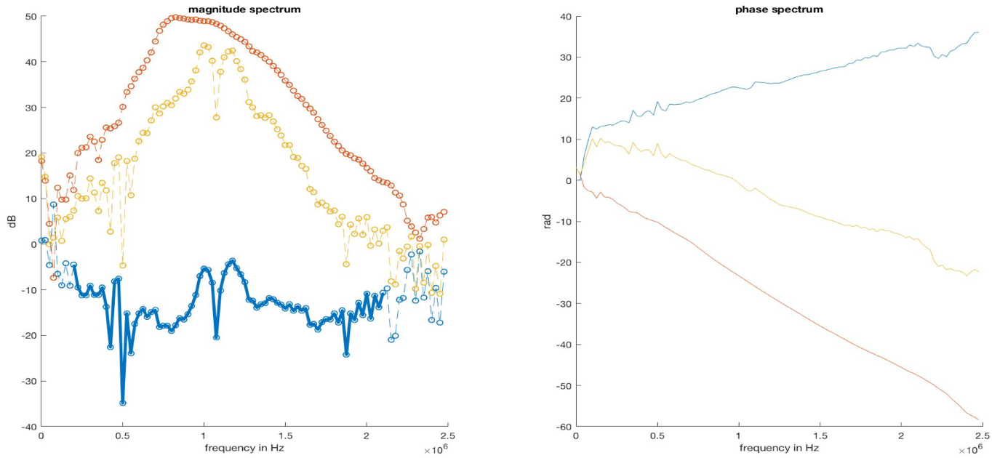

**Figure X6.**  Transmission coefficient spectra with fitted theoretical transmission coefficient of a measured glass sample.

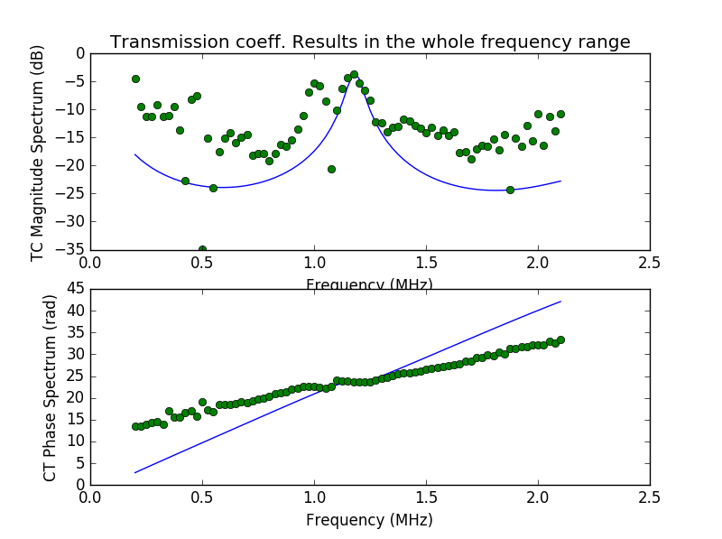

**Table X3.** The results obtained from python algorithm compared with calculated and/or literature data for further investigation on the issues of setup and/or data analysis.

|  |  |
| --- | --- |
| Parameters Python output | Calculated and/or literature data |
| Thickness (mm) 5.10  Velocity (m/s) 12186  Density (kg/m3) 3677  Resonant frequency (MHz) 1.17 | 2.76  6400  2830  1.16 |

As it can be seen from results above, the measured data curve did not fit nicely with theoretical curve as well as the python output values with calculated values. However, whole data process showed acceptable correct resonant frequencies. First experiments with affordable samples gave a common understanding emerged on the need for further research with aluminium samples with different thicknesses which were manufactured in workshop later. Further in this section the focus was on improving this results in varying degrees. The first assumption was to guarantee that the equipment, specifically pulser/receiver is working as intended, since the pulser/receiver amplifies and enhance signal-to-noise to produce clear signal on the scope.

**3.2.2. Characterisation of pulser/receiver**

The figure below depicts a front panel of pulser/receiver and shows all-wheel control button which are available on it.

**Figure X.**  The front panel of pulser/receiver indicating all the available switches on it. These toggles can be easily changed for better signal representation.

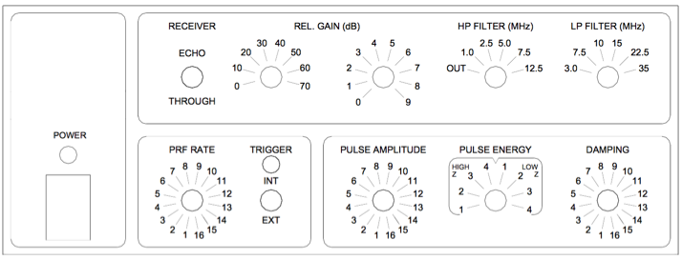

A common analytical and experimental challenges were to better understand a relationship between pulser/receiver and signal representation on the scope and how the modification of parameters on pulser/receiver can reshape the pulse signal. Under the circumstances, a series of experiments were conducted where the control switches were varied, hence the optimal variant were selected for further experiments.

**Filters (High pass filter and Low pass filter)**

High pass filter (HP filter) allows to bypass all the frequencies in the range of 1 MHz and 12.5 MHz. As stated above, the provided transducer operates in bandwidth of minimum 0.49 MHz and maximum 1.61 MHz with centre frequency of 1 MHz, thus it is obvious to set HP filter to “OUT”, since it is not desirable to lose any signal of transducer’s frequency range.

Low pass filter (LP filter) permits to bypass all the frequencies which are lower than 3 MHz as minimum and 35 MHz as maximum. Therefore, LP filter plays minor importance due to the transducer bandwidth (maximum 1.61 MHz) unless to improve the signal-to-noise ratio and cut off undesirable high frequencies when a sample is introduced between transducer and hydrophone. However, the despite the theoretical understanding of function of both filters and how it should be set, they are toggled through different values to assure that they do not make much difference on the signal representation. Filters effect is described more detailed later on this section.

**Fast Fourier transformation (FFT)**

With help of direct FFT spectrum on the scope it is possible to observe the signal in frequency domain immediately. The following settings for FFT in oscilloscope were applied:

* Span: 5 MHz (it sets the overall width of the FFT spectrum that can be seen on display)
* Centre: 2.3 MHz (it sets the FFT spectrum frequency represented at the centre of vertical grid line of the display)
* Window type: hanning (by default) It selects a window to apply to the FFT settings. There are 4 types of window:
* Hanning – window to make precise frequency evaluation.
* Flat top – window to make accurate amplitude measurements of frequency peaks.
* Rectangular - good frequency resolution and amplitude accuracy. However, only can be used where there will be no leakage effects.
* Blackman Harris – window significantly lowers the resolution compared to other types, but enhances the capacity to identify smaller impulses.

**Pulse repetition frequency (PRF)**

**Experiment 1. Changes of amplitude, energy and damping at different gain values**

***Relative gain: 0 dB (minimum)***

Initially, pulse amplitude, energy and damping were switched to 1 and the signal was not visible as shown in Figure X below.

**Figure X.** Changing the parameters of pulser/receiver to see the effects on them on result. No signal observation in the display on minimum settings of switches. Pulse amplitude = 1, energy = 1, damping = 1 and relative gain = 0 dB. Yellow line – signal. Purple line – FFT spectrum.

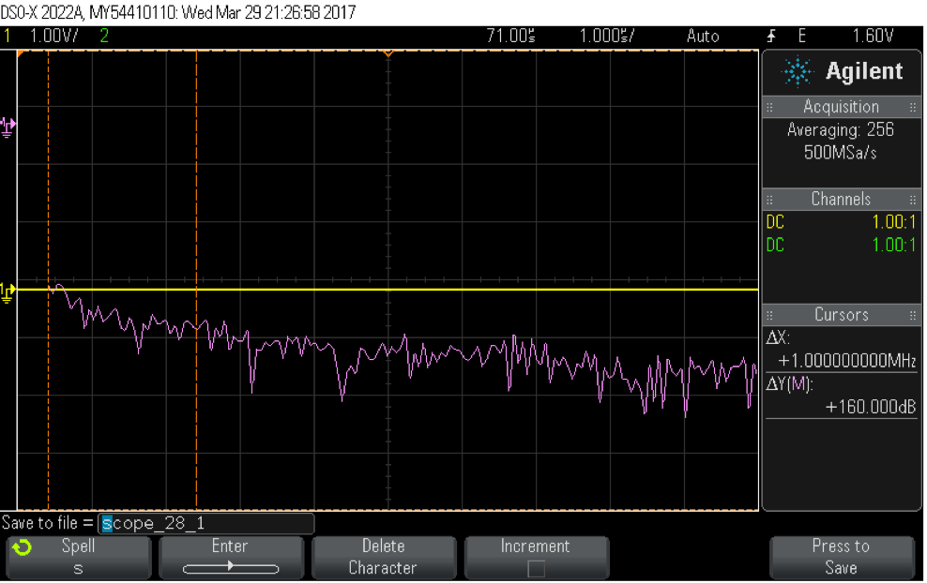

**Note:** The figures are presented only when considerable effects in signal is seen.

The minimum, medium and maximum values and their combinations of amplitude (1,8 and 16), energy (high Z 1 and 4, low Z 1 and 4) and damping (1,8 and 16) were tested.

The next step was to change energy to “high Z 4”. The actual signal is stayed unchanged, but the FFT spectrum gave response in 1 MHz. The obtained result is represented in Figure X.

**Figure X.** Changing the parameters of pulser/receiver to see the effects on them on result. Observation of FFT spectrum response on 1 MHz, but the time domain signal was still not visible. Pulse amplitude = 1, energy = high Z 4, damping = 1 and relative gain = 0 dB

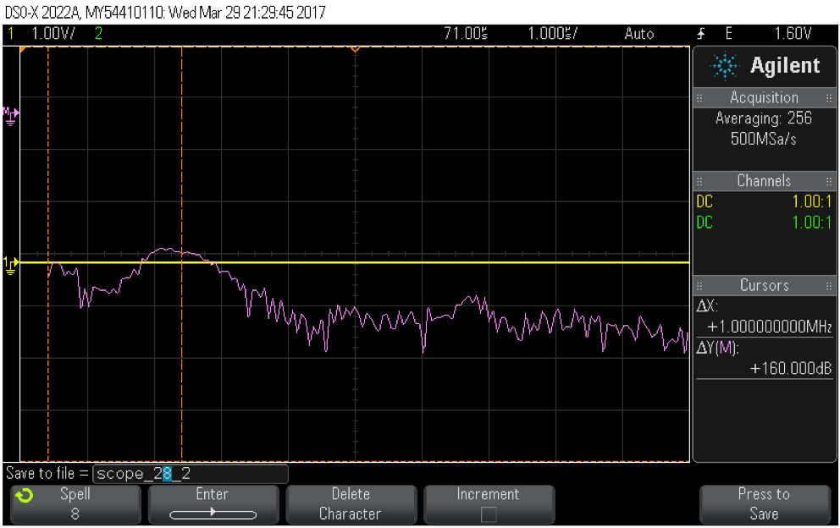

Based on same scheme, subsequent changes in parameters did not give any significant changes on the signal. After changing energy to “low Z 4” or increasing the pulse amplitude to 8 and keeping energy at “high Z 4”/”low Z 4” showed better FFT spectrum (Figure X). However, the signal was still not visible on display.

**Figure X.** Changing parameters pulser/receiver whereas the relative gain is 0 dB did not give any significant change but only in FFT spectrum. Observation of FFT spectrum response on 1 MHz, but the time domain signal was still not visible. Amplitude = 16, energy = 1 and damping = 1

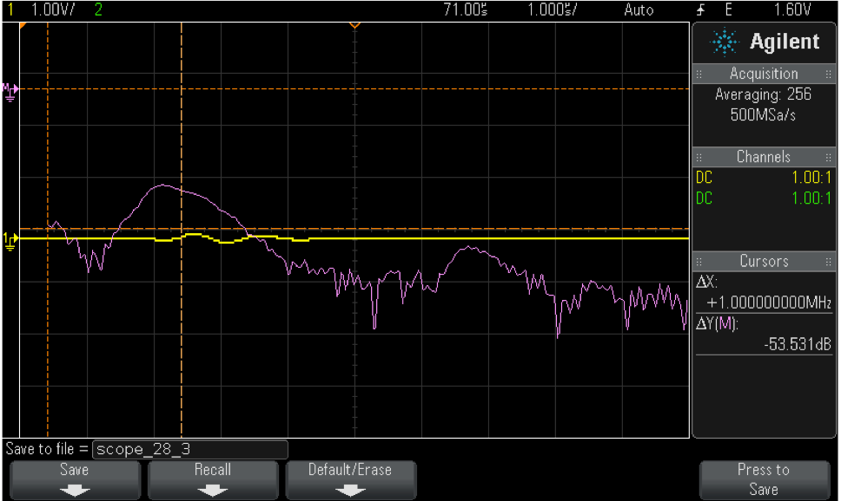

***Relative gain: 79 dB (maximum)***

This time, the relative gain was set to 79 dB to observe considerable changes in signal in all possible combinations (minimum, middle and maximum) and to ensure that 79 dB is not appropriate setting to be chosen (Figure X).

**Figure X.** The signal in time domain were displayed inadequately since some of the peaks were distorted and clipped. Pulse amplitude = 1, energy = high Z 4, damping = 1

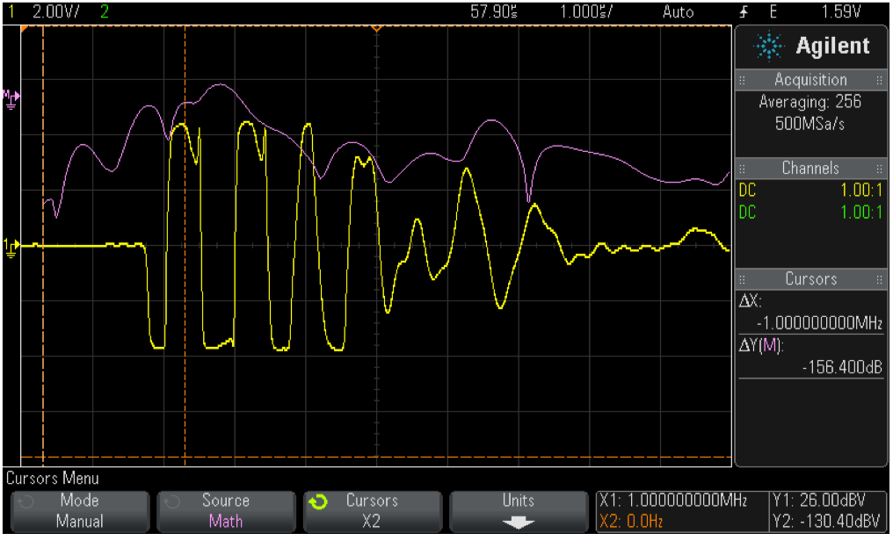

Note: several toggles were changes in pulser section to retrieve good signal representation, but a similar results as in Figure were obtained.

***Relative gain: 39 dB (middle)***

Building on above results, this time the relative gain was set to 39 dB. A remarkable change was observed and noted. Based on 39 dB, all the possible combinations for amplitude, energy and damping were attempted and the optimal variant was selected for future experiments. All the combinations’ figures are attached in Appendix in the end of this report.

Amplitude. As expected, the signal and FFT spectrum’s amplitude increases with increasing amplitude value, independently on other settings. If the amplitude is turned to 8 and energy is “low Z 4” or amplitude is 16 in all cases, then the signal is clipped and FFT spectrum changes respectively.

Pulse energy. Increasing energy from 1 to 4 (high and low) increases the amplitude of the signal. In some combinations, FFT shape changed a little, especially with “low Z” values or with maximum amplitude (16). The possible reason for that might be the clipping and distortion of the signal in time domain.

Impedance. It was observed that with “low Z” values, the amplitude is bigger than with “high Z” values. And that is in line with manual stating that “low Z” impedance provides better signal strength.

Damping. With rising damping values applied to the transducer, the signal’s amplitude was decreased. Also according to the datasheet, the “high Z” impedance values provides better damping to a transducer, hence the amplitude appears to be smaller than with values of “low Z”.

Hence, following all the above experimentations, a decision was made to select following setting for pulser/receiver:

* Relative gain: 39 dB
* Pulser amplitude: 8
* Pulser energy: low Z 4
* Damping: 16

The signal with aforementioned parameters were satisfying, because the amplitude was high enough as well as the pulse energy as it was set to low impedance (not high) so it displayed sharp signal and the maximum value (4) for impedance was chosen, so that it was expected to cover a wider range of frequencies even though this phenomenon was not visible in the oscilloscope. Likewise, the signal representation with these parameters was compared with signal look in calibration sheet of transducer (Figure X).

**Figure X.** Comparison of two signals: left is signal in calibration sheet and right is signal with chosen parameters for pulser/receiver. As it can be seen from the figures they are to certain extend identical.

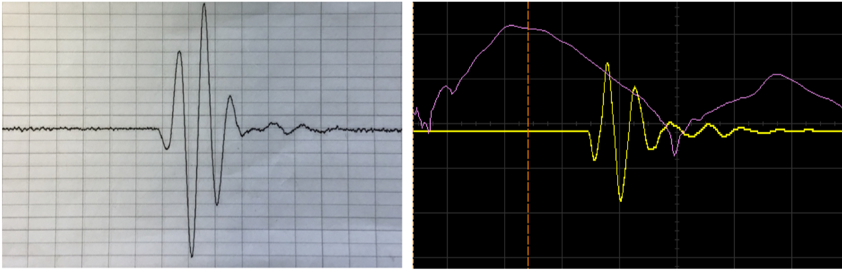

**Experiment 2. Effect of filters (HP and LP) on the settings**

Once the parameters were determined, an experiment with filters were carried out. As expected, no change in the signal was observed while changing values of LP filter. However, as a precaution, LP filter was set to 3 MHz to filter out high frequencies (noise) when a sample is inside the tank.

HP filter was experiment with 1 MHz (minimum), 2.5 MHz and 12.5 MHz (maximum) frequencies. As could be expected, the signal was distorted when frequency below 1 MHz, although the cut-off was not so strict, since there was some signal left. On other hand, increasing the HP filter value further eventually made the signal to disappear completely (Figure X).

**Figure X.** Comparison of three setting of HP filter. As it can be seen from three figures below, that with increasing value of filter the signal vanishes at maximum value.

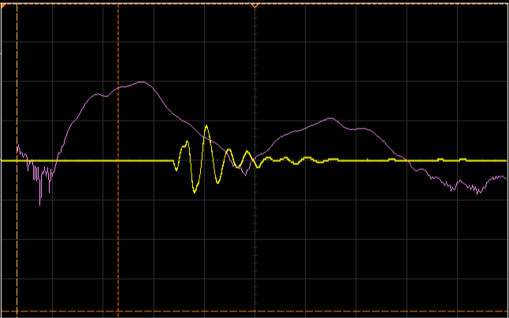 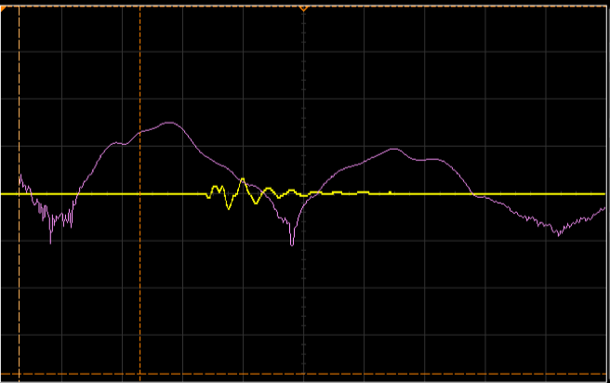

**HPF is 1 MHz HPF is 2.5 MHz**

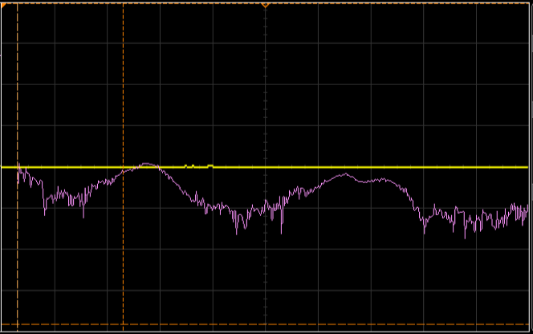

**HPF is 12.5 MHz**

**3.2.3. Experiments on aluminium samples**

After series of experiments on characterisation of pulser/receiver equipment and selecting the viable option of parameters at this stage of work, four aluminium models with different thicknesses were manufactured to test with new parameters.

Aluminium samples with thickness of 2, 3, 4 and 5mm were tested and a data was processed accordingly.

**Experiment 1. Aluminium with 2mm thickness**

**Figure X.** Detail in the phase and magnitude spectrum of the first received pulse without and with sample between transducer and hydrophone. The graph shows MATLAB output

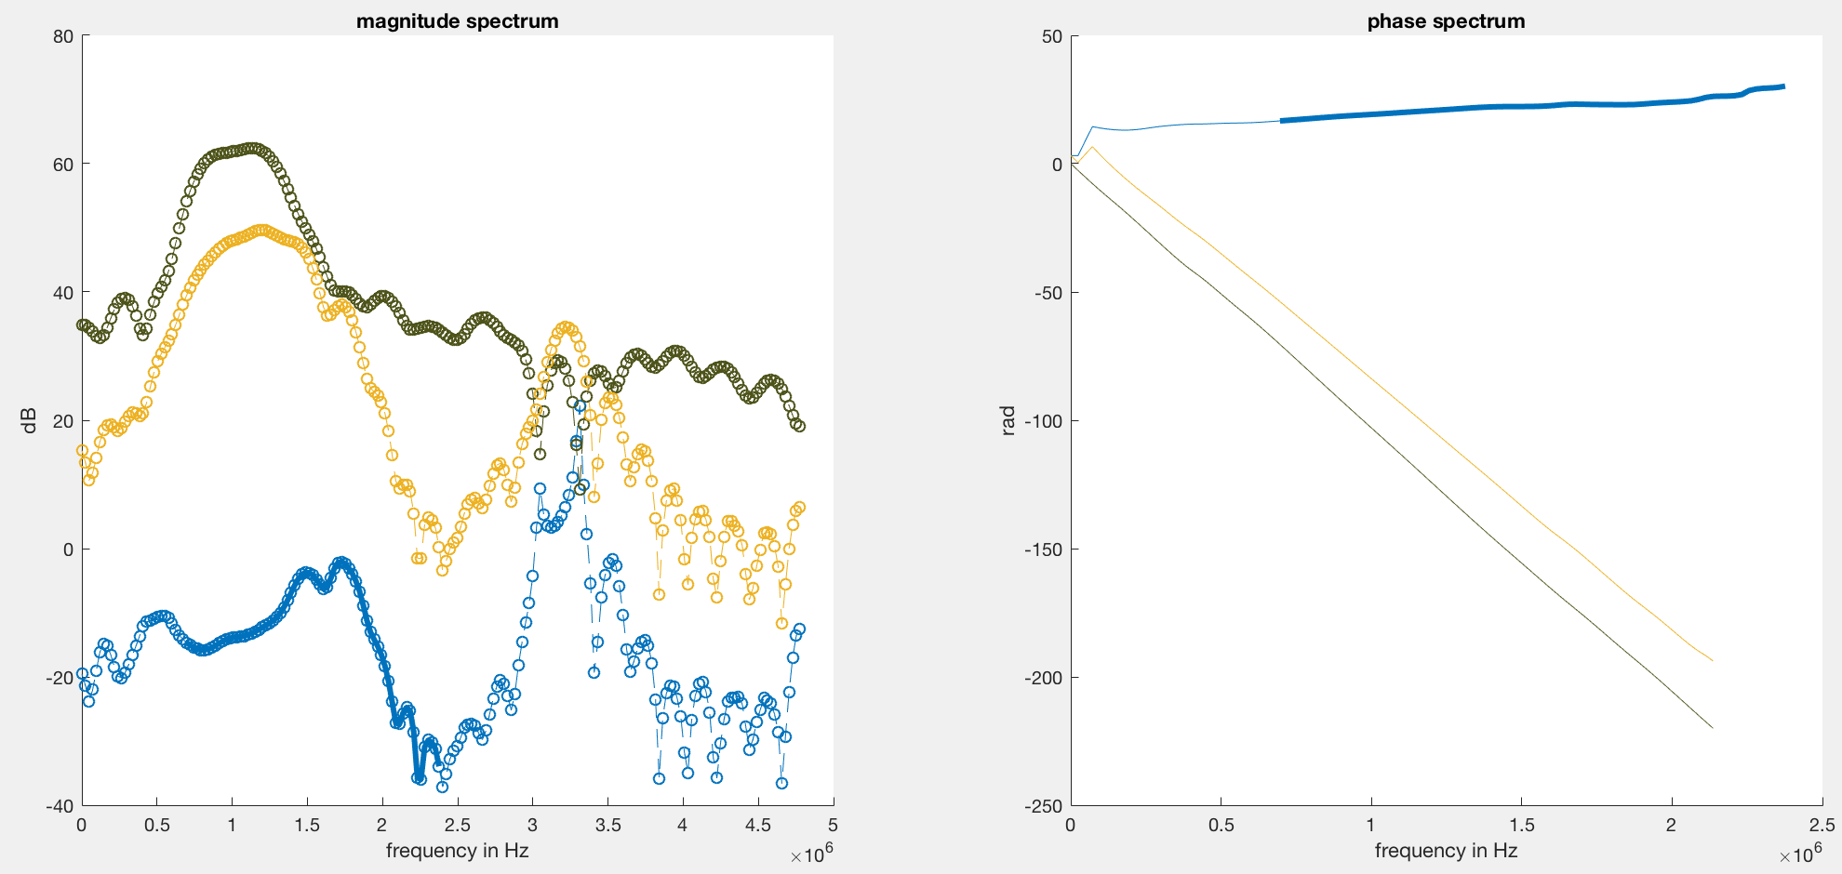

**Figure X3.**  Transmission coefficient spectra with fitted theoretical transmission coefficient of a measured glass sample.

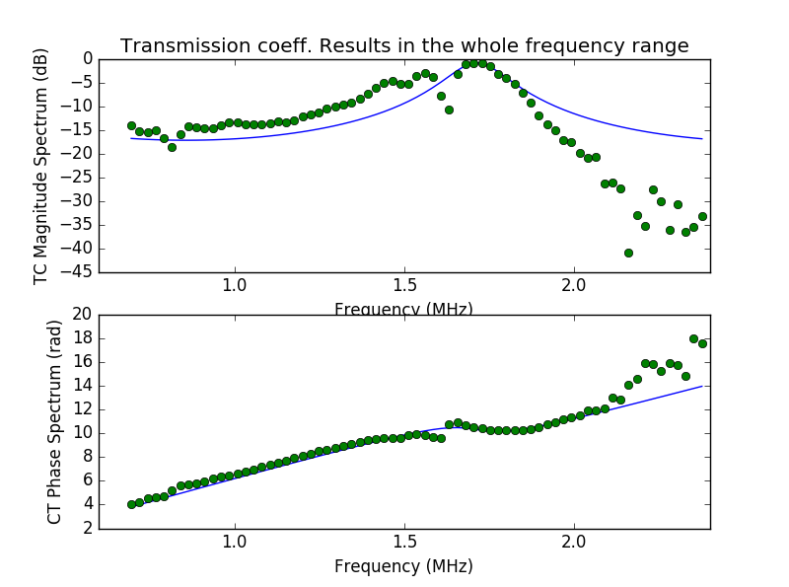

**Table X3.** The results obtained from python algorithm compared with calculated and/or literature data for further investigation on the issues of setup and/or data analysis.

|  |  |
| --- | --- |
| Parameters Python output | Calculated and/or literature data |
| Thickness (mm 1.786  Velocity (m/s) 6175  Density (kg/m3) 3376.6  Resonant frequency (MHz) 1.173 | 1.76  6400  2994  1.16 |

**Experiment 2. Aluminium with 3mm thickness**

**Figure X.** Detail in the phase and magnitude spectrum of the first received pulse without and with sample between transducer and hydrophone. The graph shows MATLAB output. A comparison of two results of MATLAB with old settings of pulser/receiver (left) and new (right).

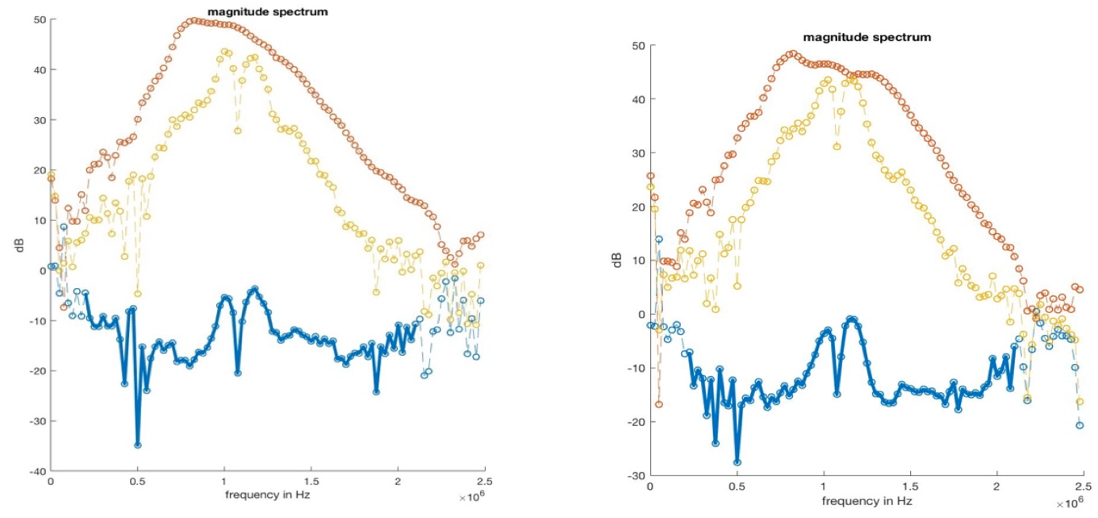

**Figure X3.**  Transmission coefficient spectra with fitted theoretical transmission coefficient of a measured glass sample. A comparison of two python output graphs; old setting of pulser/receiver and new respectively.

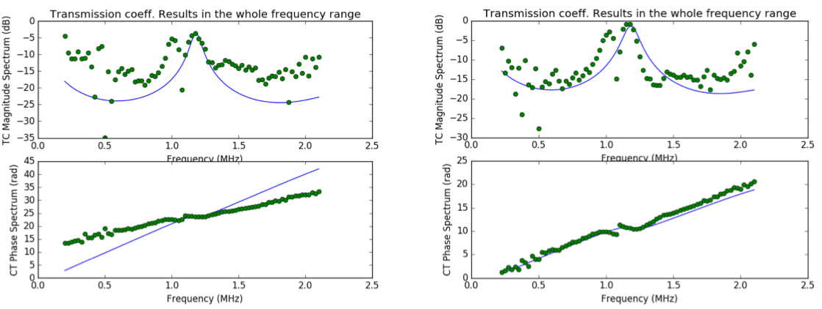

**Table X3.** The results obtained from python algorithm compared with new settings results and calculated and/or literature data for further investigation on the issues of setup and/or data analysis.

|  |  |  |
| --- | --- | --- |
| Parameters Python output (old settings) | Python output (new settings) | Calculated and/or literature data |
| Thickness (mm 5.1  Velocity (m/s) 12186  Density (kg/m3) 3677  Resonant frequency (MHz) 1.17 | 2.6  6292  3527  1.15 | 2.76  6400  2800  1.16 |

**Experiment 3. Aluminium with 4mm thickness**

**Figure X.** Detail in the phase and magnitude spectrum of the first received pulse without and with sample between transducer and hydrophone. The graph shows MATLAB output

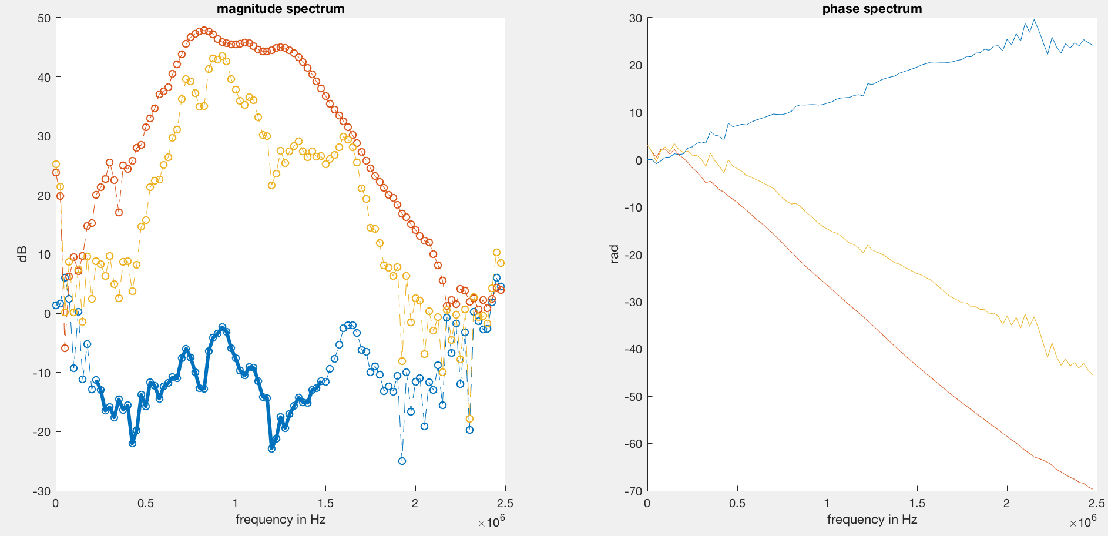

**Figure X3.**  Transmission coefficient spectra with fitted theoretical transmission coefficient of a measured glass sample.

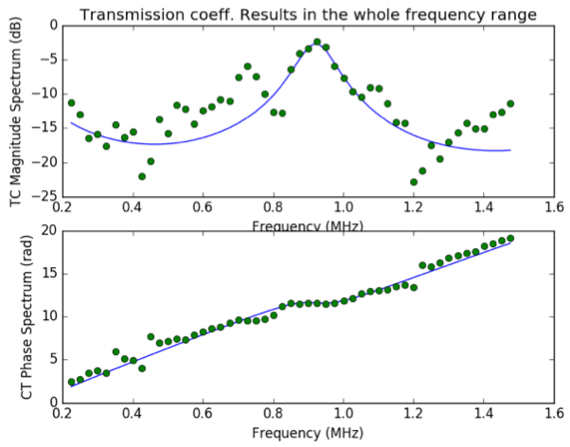

**Table X3.** The results obtained from python algorithm compared with calculated and/or literature data for further investigation on the issues of setup and/or data analysis.

|  |  |
| --- | --- |
| Parameters Python output | Calculated and/or literature data |
| Thickness (mm) 3.62  Velocity (m/s) 6776  Density (kg/m3) 3135  Resonant frequency (MHz) 0.93 | 3.76  6400  2868  0.85 |

**Experiment 4. Aluminium with 5mm thickness**

**Figure X.** Detail in the phase and magnitude spectrum of the first received pulse without and with sample between transducer and hydrophone. The graph shows MATLAB output

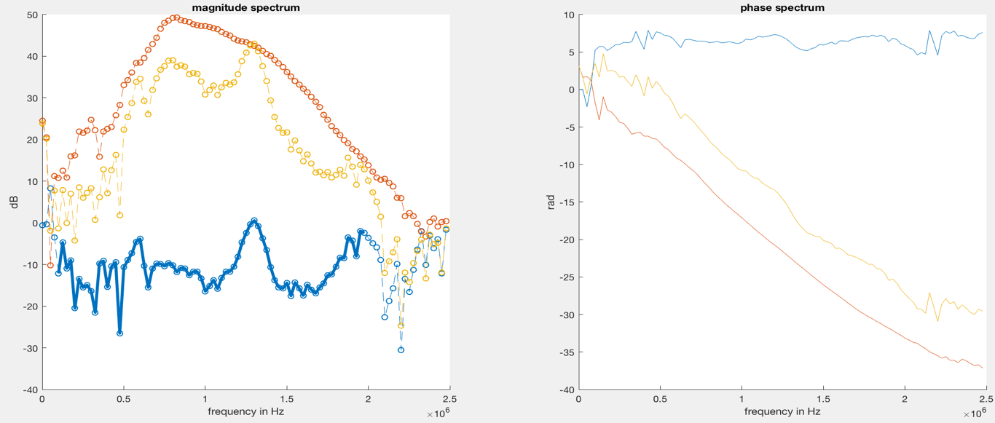

The expected resonance frequency for 5mm thick aluminium was calculated and found to be at 0.67 MHz. However, as MATLAB graph shows the highest peak appears to be at around 1.3 – 1.4 MHz, which makes sense, since the transducer’s centre frequency is at 1 MHz and it recognized 1.3 – 1.4 MHz as a first order thickness resonance when in fact it is the second order resonant frequency (0.67 + 0.67 = 1.34 MHz).

The experiments with different thicknesses of samples was aiming to prove again the section about transducer’s theory that its functioning abilities to cover the range of specific frequencies. Furthermore, the experiment on 3mm thick aluminium showed better results than it was before. It is possible to compare the results indicated in Table X and it can be seen that the values are close to calculated/literature data with modified pulser/receicer setup.

On closer scrutiny, one will also find that the magnitude graph of each samples has tend to have two peaks instead of one expected. The presumed reason for this effect was that the incident beam was not hitting a sample at normal degree. The interference, indicated with red circle in the middle of two peaks (Figure X), is due to the appearance of a shear wave.

**Figure X.** The shear wave appearance on the FFT spectrum due to the tilted sample which causes the incident pulse to arrive not at right angle. Aluminium with 3mm thickness.

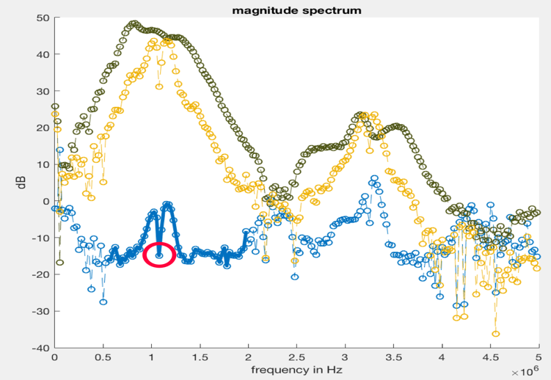

The possible solution, at that stage of work, to get rid of shear wave effect was to position a sample while FFT spectrum is on in oscilloscope directly, so it is possible to note whether the effect is eliminated or not. In additional to that the effect of some filters which were implemented in MATLAB helped to snap out of it. Supplementary, the setup was enhanced so that the sample, transducer and hydrophone holders are not movable anymore so there is no chance for any of them to be tilted at any angle.

**3.2.4. Setup improvements to reduce the effect of shear wave**

The setup was subject to improve the holders for each equipment so they are stationary in terms of tilting. In additional, in initial setup, the sample holder was fixed on the scaffold, hence to change a sample the entire structure had to be removed from water which was fundamentally unfeasible.

The setup was sent to university workshop for modification. The Figure X shows initial and modified setup.

**Figure X** shows the first setup with side and top views (with yellow holders) as well as modified setup with grey holders.

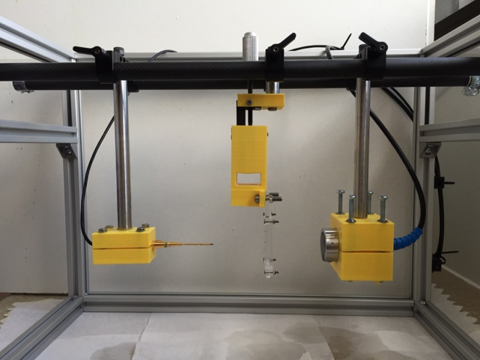 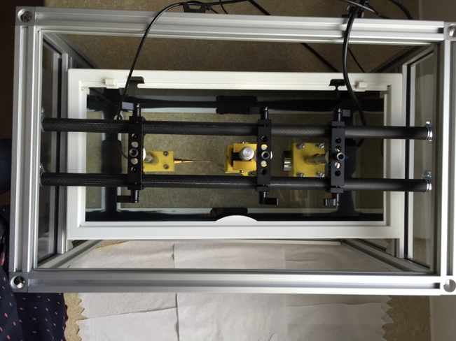

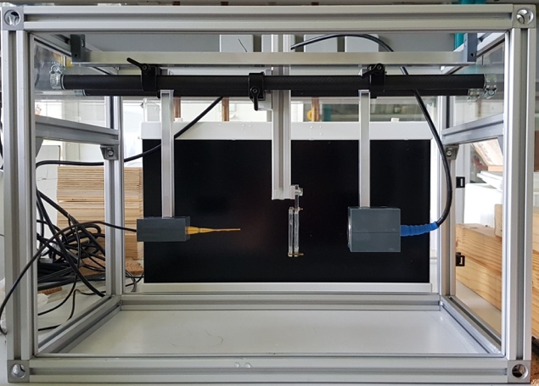 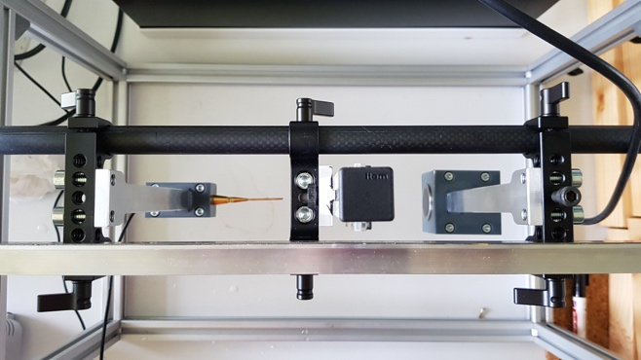

In modified version of setup the holders for sample, transducer and hydrophone are stationary so they cannot be tilted to any angle which theoretically prevents any shear wave to happen. In additional, the modified sample holder now can be independently removed from whole structure while changing of a sample whereas in initial setup the whole structure had to be removed from a water tank in order to replace a sample.

Following the improvement, the experiments were conducted on all aluminium samples once again to observe any changes in FFT spectrum in terms of shear wave phenomena. The MATLAB output graphs are shown below in Figure X.

**Figure X** represents output FFT graph from MATLAB script where the experiments were performed with updated setup concerning variation of angles which causes shear waves.

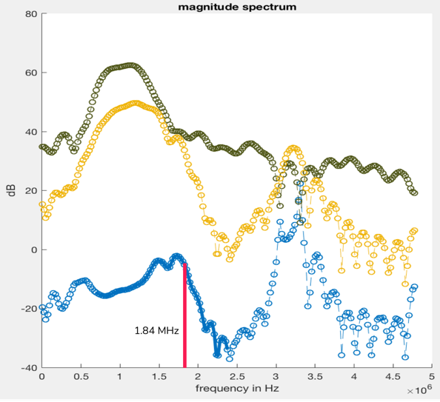 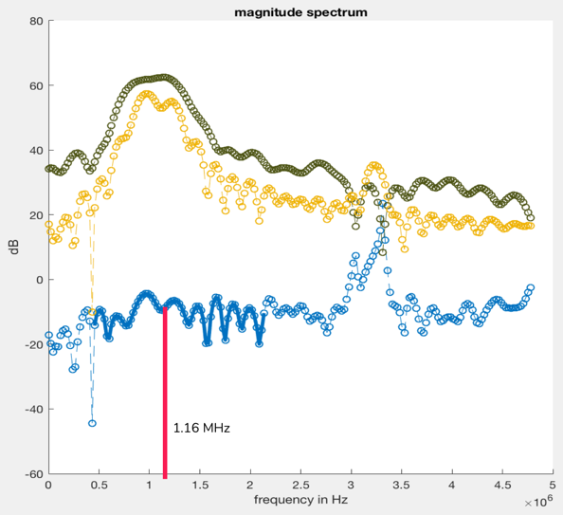

**aluminium 2mm aluminium 3mm**

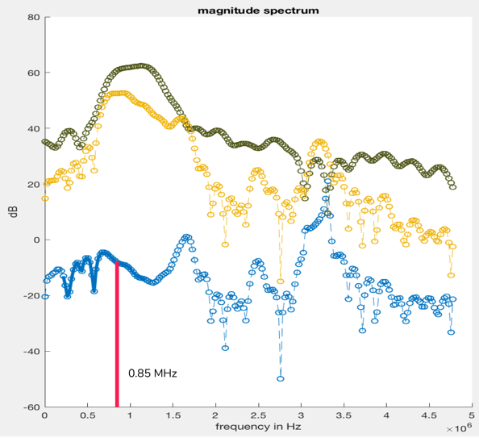 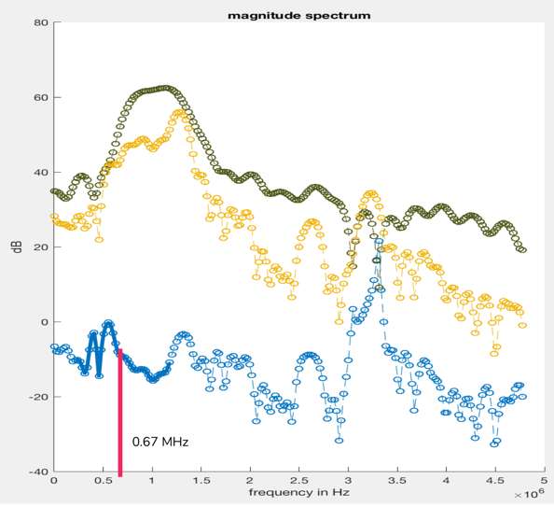

**aluminium 4mm aluminium 5mm**

The above MATLAB results shows that enhanced holders in structure indeed made some improvements in reducing shear wave effect, specifically for 2mm and 3mm thick samples. However, it is possible to observe that there were still two peaks on samples with 4mm and 5mm thick aluminium. To solve this issue filters implemented in MATLAB were used. The filters described in the next section.

**3.2.5. Data analysis improvements to reduce the effect of shear wave**

In order to remove the effect of shear wave several methods were tested. Initial solution for that was to filter out a side noises (Figure X) around the peak. There was the reason which causes for python algorithm to fit theoretical curve with measured data not nicely.

**Figure X.** The red rectangular figures on graph represent the noises which has to be removed with help of a filter

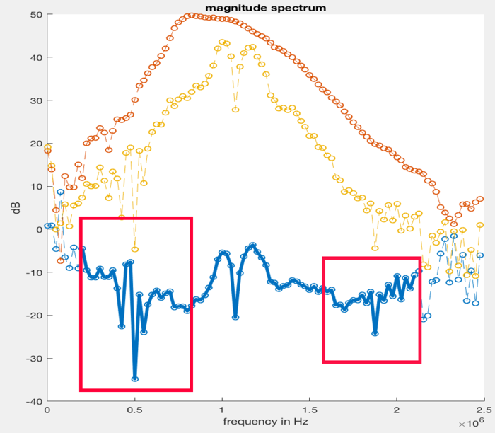

**Hampel filter to remove outliers**

This is a fundamental filter based on a symmetric moving window has only one parameter what can be varied: the window width. Despite this boundary with window, this filter has proven to be extremely useful in the past researches. The hampel filter substitutes middle point value in the data window with the median in the case when it lies in fair distance from the median to be considered as an outlier.

For any input data, the filter computes window of median collected of current input data points and “(window length -1)/2” neighbour data points on each side of current point. Supplementary, the filter algorithm estimates the standard deviation of each point on a measured data about its window of median with a help of the median absolute deviation. If a current data point deviates from the median more than the threshold value multiplied by the standard deviation, the filter relocates the point to the median point.

Simple algorithm on function of filter as follows:

There is a sequence of data points *x1, x2, x3 ,…., xn* and sliding window length of *k*, determine point-to-point median and standard deviation calculates based on:

* Local median (*mi*) = median (*xi-k, xi-k+1, xi-k+2, … , xi, …. , xi-k-2, xi-k-1, xi+k*)
* Standard deviation (σi) = κ(median absolute deviation), where κ is 1.4826

**Figure X.** Given sequence of data points with centre point (median) Xi and k is neighbouring points on each side where the Hampel filter is applied to identify an outlier.

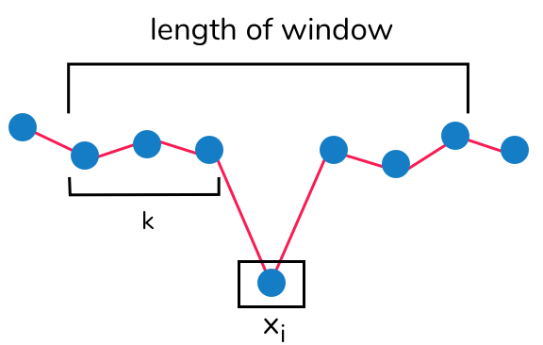

If *xi* point is placed so:

|*xi  - mi*| > *nσσI*

for given threshold value nσ, then Hampel filter recognize xi as an outlier point and replace it with mi.

The Hampel filter was implemented in MATLAB software and integrated in old script to observe results immediately, in this example for measurements aluminium 3 mm thickness was used.

The script below represents implemented Hampel filter in MATLAB to remove outliers from FFT spectrum. It has been done to take away noises around the peak for appropriate fitting in Python algorithm

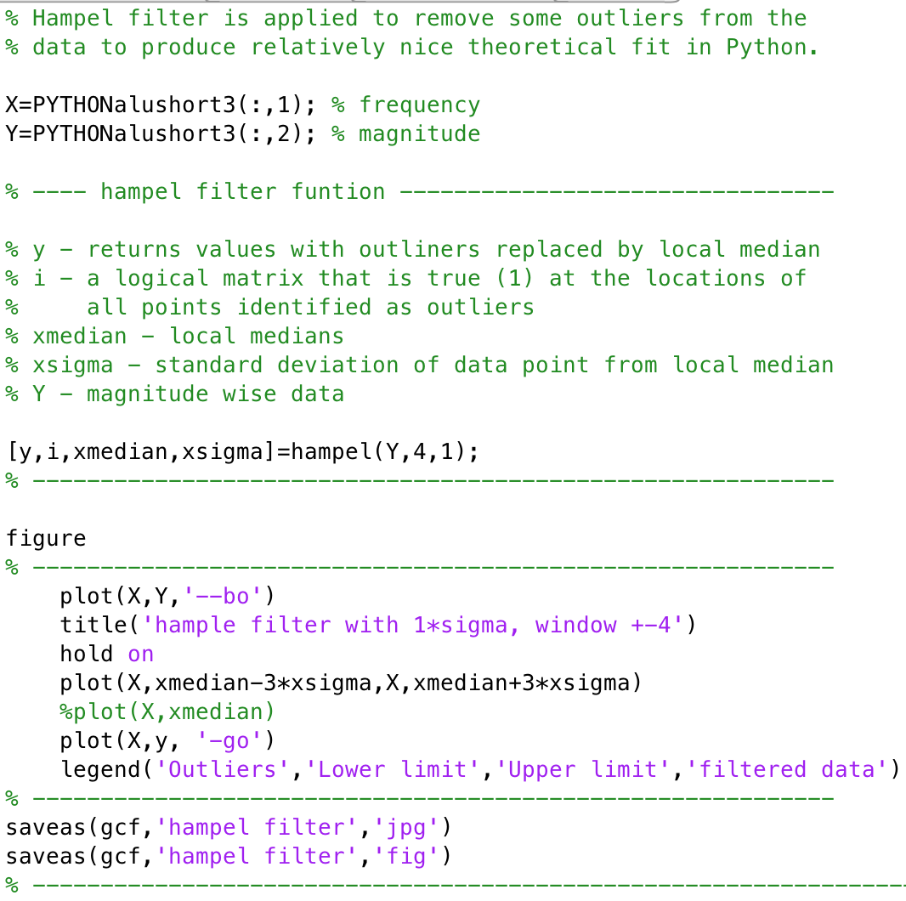

The outcome of the filter can be seen in Figure X below.

Figure X. The Hampel filter applied to FFT signal. The green dots shows already filtered data whereas the blue dots represents outliers which were shifted to the median value.

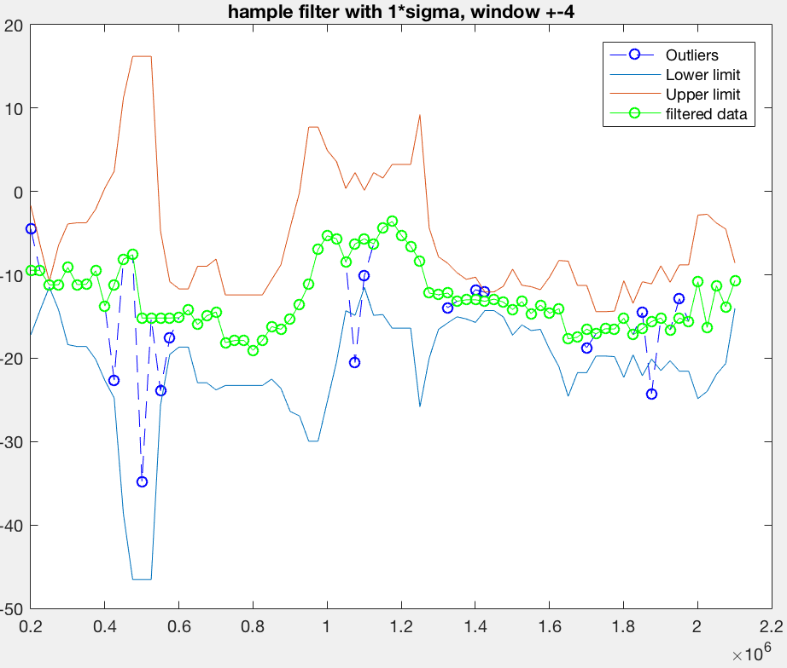

As can be seen from above graph, the Hampel filter is functioning in the way it was intended. The example shows before tested aluminium sample and filter was applied on top of it. In the given example threshold value is equal to 1(*nσ*), hence it is a number of standard deviation, by which the original data points (Y in the script) must differ from the local median for it to be switched with the median. Therefore, the graph has two limits, upper (orange line) and lower (light blue line) limit.

The green circled signal on the graph represents filtered data where all the outliers were removed successfully. And the dark blue circles were distinguished as outliers, since their location were far enough from threshold.

The sigma and window length values for Hampel filter are completely tuneable, so the figures below represent results with different values of sigma and window length.

**Figure X** shows 4 different graphs where Hampel filter with varied parameters were applied. The green circled signal is filtered data where outliers (blue circles) were replaced by median value. The orange line is upper limit of median and light blue line is lower limit of median. The graph a) is a standard deviation of 2 and 6 neighbouring points on each side, b) is standard deviation of 3 and 3 neighbouring points on each side, c) is standard deviation of 2 and 3 neighbouring points on each side and d) is standard deviation of 1 and 6 neighbouring points on each side.

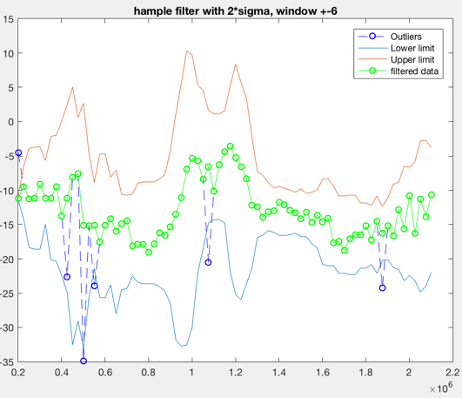 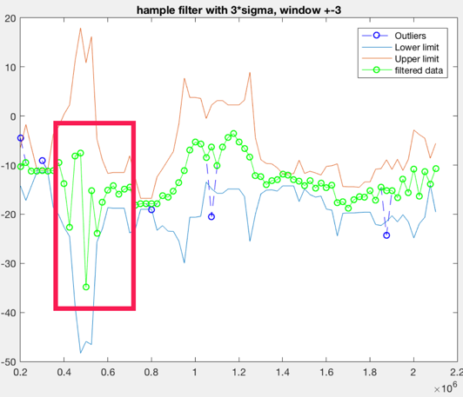

1. b)

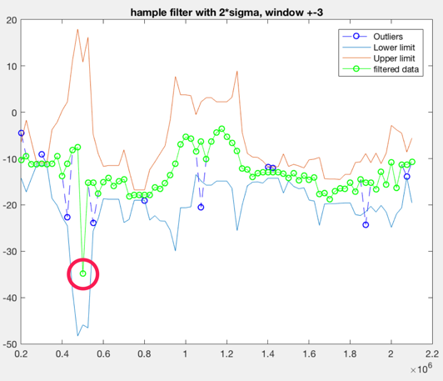 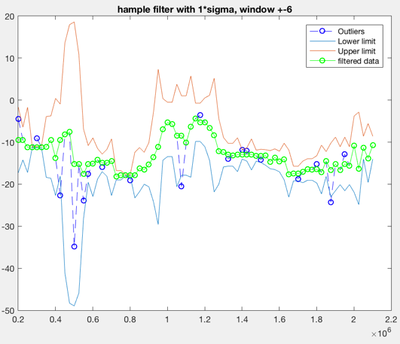

1. d)

As it can be seen from the graphs above, the differentiation under specific sigma values and window length is distinct. Specifically, it is clearly visible on picture b) and c). In picture b) it is obvious that with increasing sigma value and outliers in red box are staying in boundary, hence they are not replaced with median. On an another hand, decreasing sigma value to 2 and keep the window length same in picture c) shows it removed some outliers, since original data points can only differ from the local median by 2 data points of standard deviation, but red circle shows that the outlier point is still there. However, that can be easily resolved by reducing standard deviation number further down to 1 as in picture d) either increasing window length as in picture a).

**Conclusion and future work**